Civil Engineering AI Studio

1. INTRODUCTION
1.1 Project Overview
Civil Engineering Insight Studio is an AI-powered web application developed to analyze construction and structural images and provide professional insights. The system uses advanced vision-language models to interpret uploaded images and generate descriptive and technical information related to civil engineering structures.
The application is built using Streamlit for the frontend and NVIDIA NIM Vision models for backend image processing. It allows users to upload images, analyze them, and maintain a history of reports.

1.2 Purpose
The main purpose of this project is to:
Assist civil engineers in preliminary site inspection.
Provide instant visual analysis using AI.
Reduce manual effort and inspection time.
Maintain digital records of inspections.
Support academic and professional learning.

Team ID : LTVIP2026TMIDS24071
Team Members :
- Badarla Vinay Surya
- Badavath Sai Karthiknehru
- Bala Vardhan Kumar Doupati
- Bandi Anand Babu
2. IDEATION PHASE
2.1 Problem StatementTraditional site inspection requires physical presence, expert knowledge, and significant time. Manual analysis is prone to human error and documentation issues. There is a need for an automated system that can analyze structural images and provide technical insights quickly and accurately.
2.2 Empathy Map Canvas
Category | Description
Thinks | How to analyze sites quickly?
Feels | Worried about safety and quality
Says | Inspection takes too much time
Does | Takes photos and notes
Pain | Delays, errors, documentation
Gain | Faster inspection, reports

2.3 Brainstorming
During brainstorming, various ideas were discussed:
- Mobile inspection app
- Drone-based monitoring
- AI-based image analyzer
- Automated report generator
- Cloud-based inspection system
- The final idea selected was an AI-based image analysis platform.
3. REQUIREMENT ANALYSIS
3.1 Customer Journey Map
User opens application

Uploads site image

Enters prompt (optional)

Clicks analyze

Receives report

Saves history

Exports PDF
3.2 Solution Requirement
Hardware Requirements
- Computer / Laptop
- Internet connection
Software Requirements
- Python 3.10+
- Streamlit
- NVIDIA API
- Requests Library
- PIL
- ReportLab
3.3 Data Flow Diagram
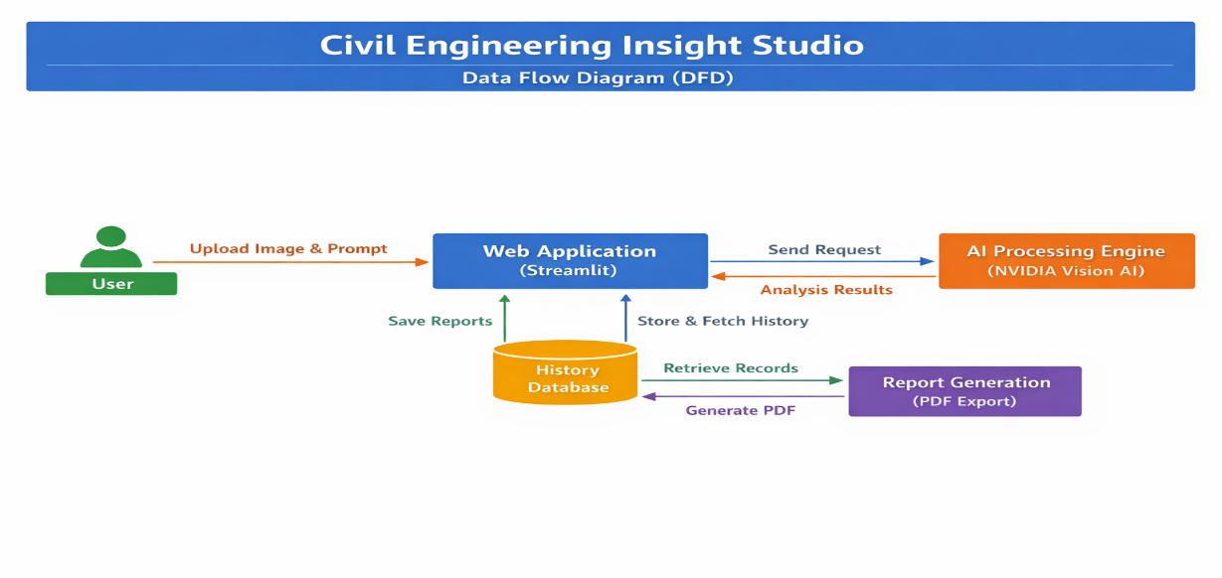
3.4 Technology Stack

Component | Technology
Frontend | Streamlit
Backend | Python
AI Model | NVIDIA NIM Vision
Storage | JSON File
PDF Export | ReportLab
Image Processing | PIL
API | REST API

4. PROJECT DESIGN
4.1 Problem Solution Fit
The proposed solution provides an automated, accurate, and fast way of analyzing civil engineering images. It reduces dependency on manual inspection and improves productivity.

4.2 Proposed Solution
- The system allows users to:
- Upload images
- Send them to AI model
- Receive technical description
- Store reports
- Export reports
- This creates a complete inspection workflow.
4.3 Solution Architecture
User Interface (Streamlit)

Image Processing (PIL)

NVIDIA Vision API

Response Processing

Local Storage (JSON)

PDF Generator

5. PROJECT PLANNING & SCHEDULING
5.1 Project Planning
Phase | Duration
Requirement Analysis | 1 Week
Design | 1 Week
Development | 2 Weeks
Testing | 1 Week
Deployment | 1 Week
Documentation | 1 Week

6. FUNCTIONAL AND PERFORMANCE TESTING
6.1 Performance Testing
Response time: 3-20 seconds
Image upload speed: < 2 seconds
PDF generation: < 3 seconds
Concurrent users: Limited (Local)
Testing confirmed stable performance.

7. RESULTS
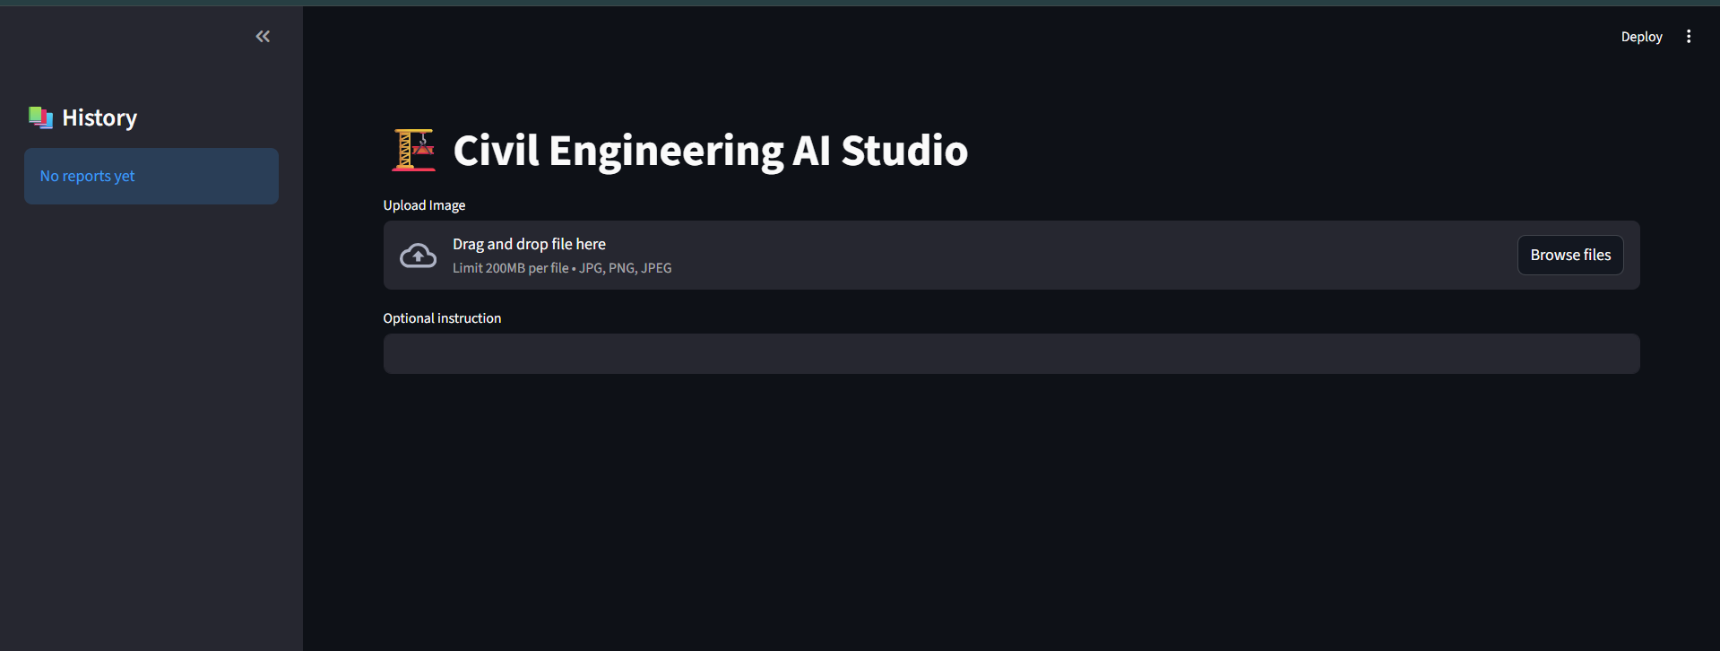
Home Screen

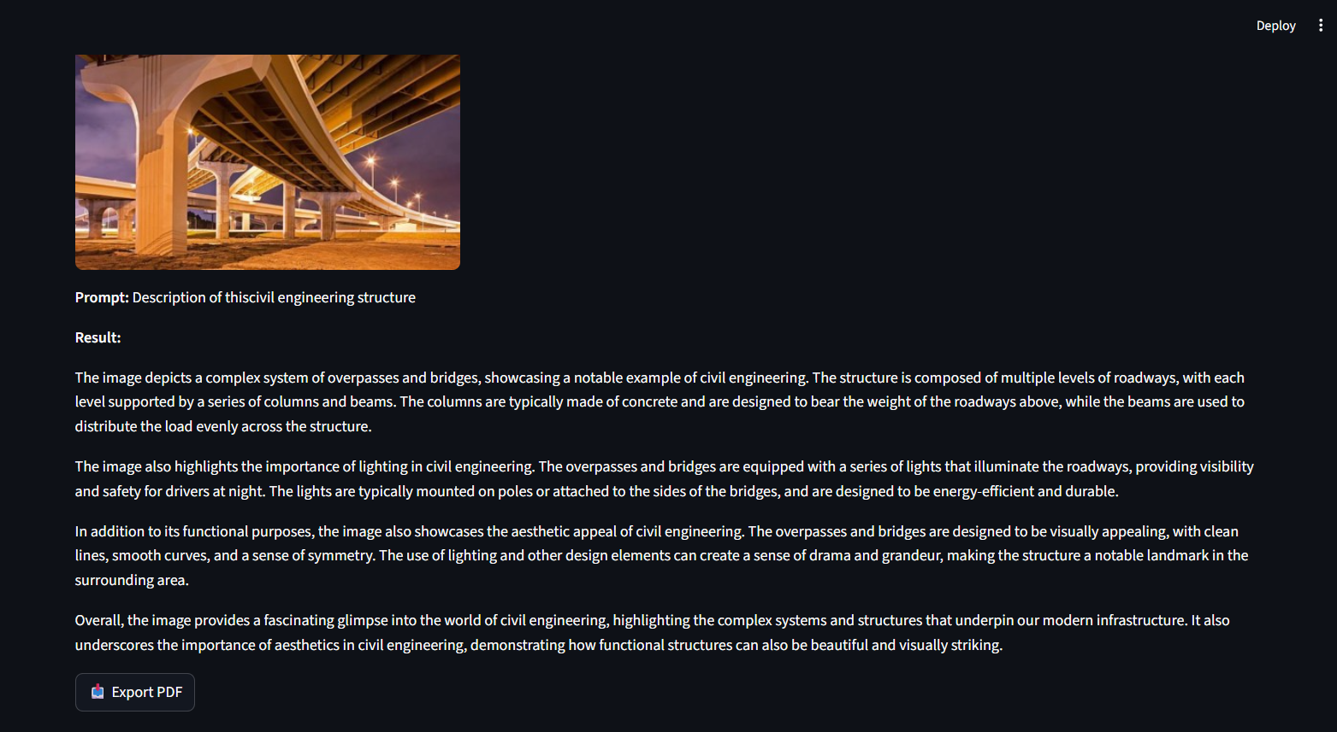
Analysis Result

History Panel
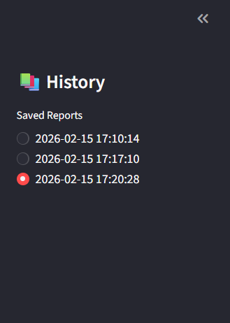
8. ADVANTAGES & DISADVANTAGES
Advantages :
- Fast inspection
- Easy to use
- Automated reports
- Low cost
- Portable system
- Digital records
- Disadvantages
- Requires internet
- Depends on AI accuracy
- Limited free API usage
- No physical verification

9. CONCLUSION
The Civil Engineering Insight Studio successfully demonstrates how artificial intelligence can be applied to civil engineering inspection. The system reduces inspection time, improves documentation, and assists engineers in decision-making.
It is a reliable tool for preliminary assessment and academic learning.

10. FUTURE SCOPE
Future enhancements include:
- Mobile application
- Multi-user login
- Cloud database
- Drone integration
- Real-time video analysis
- BIM integration
- IoT sensor data integration
11. APPENDIX
Software Libraries
Streamlit
Requests
PIL
ReportLab
dotenv
API
NVIDIA NIM API
References
NVIDIA AI Documentation
Streamlit Documentation
Python Documentation

GitHub Link:

https://github.com/Bskn1412/CEAS-smartbridge.git

Bskn

